Senior Project

Isis Adams

Department of Information Technology: Campbell University

ITS 465: Senior Project

Dr. Varma

April 21, 2021

**Abstract**

Amongst the tragedy of the unpredictable Covid-19 pandemic, businesses were shut down, people lost jobs, and there were mass lockdowns worldwide. Being stuck in the house with nothing to do became a common trend in families. Outdoor activities were in high demand, board games and gaming systems were sold out everywhere. To narrow some of the outdoor activity demand, I decide to create a business that was bound to keep someone occupied. On a farm full of leisure riding horses, I decided to open it up to more than just myself.

By allowing my family and friends to join me in these outdoor adventures, I could not only make money, but people would be getting out of their homes to do more than sit on the couch. Demand became overwhelming, especially since we must maintain a safe distance from each other, something to keep track of demand would’ve been great. For my project. I decided to build a database with an advertisement website as the interface. On the last page of the website, potential clients would be able to sign up for more information, using their name and emails, I can get back to them with any possible availability. Once they hit the “submit” button, their contact information would go into a database where I could view it later as many times as needed.

TABLE OF CONTENTS

ABSTRACT 2

LIST OF TABLES AND FIGURES 4

CHAPTERS

CHAPTER 1 – Introduction 5

CHAPTER 2 – Feasibility Analysis 6

CHAPTER 3 – Assumptions and Limitations 8

CHAPTER 4 – Detail Study and Analysis of System 9

CHAPTER 5 – Fact Finding and Data Gathering 10

CHAPTER 6 – Logical Design 11

CHAPTER 7 – System Modeling 14

CHAPTER 8 – Physical Design 18

CHAPTER 9 – User Interface Design 24

CHAPTER 10 – Implementation (Conversion/Integration) 41

CHAPTER 11 – Systems Testing and Evaluation 38

CHAPTER 12 – System Support Procedures 38

CHAPTER 13 – User Survey 38

CHAPTER 14 – Future Enhancements 38

CHAPTER 15 – Conclusion 38

APPENDICES

Appendix A – Repository 75

Appendix B – Sample Input 80

Appendix C – Sample Output 81

Appendix D – References 81

**List of Tables and Figures**

**Introduction**

In my four years at Campbell University I have had the opportunity to showcase my talent which was instilled in me by my awesome professors. As a second year ITS student, I have had to push myself to the limits, not only to create quality work but to stand out among my peers. This has been a challenging experience and I am more than grateful to have been able to do it. This senior project, for me, has been extremely difficult but I think it shows exactly what key components I will carry with me following graduation day.

My initial project proposal was surrounding a construction business which I would assist by creating a database to decrease overspending and increase profit margin. In the process of creating an updatable database made simple for a non-technical user, I was making things more difficult than they had to be. Realizing I would not be able to produce quality work, I decided to make a few changes to my project. Instead of building a database for another company which I would not be very familiar with, I decided to build this database for my own organization.

I am an equestrian trainer in training and I would love to start having clients show their interest, so I can get a feel for the type of people I will be training. I created a website using Visual Studio Code and was able to link a database to it to track interest and collect contact information. To avoid starting my project from the very beginning, I am using the same style of project just with a different scenario. Potential clients will visit my webpage, read through the information displayed and they can sign up for more information. After filling out the form, their information will then be stored in a database for me to view, update, and utilize for the advancement of my business. To coincide with my initial proposal, I will be decreasing overspending in my business by creating my own advertisement and increasing profit margin by soliciting clients and tracking their interest.

**Feasibility Analysis**

DLP Riding Lessons was founded by myself, Isis Adams, in 2020. I founded this business in honor of my late grandfather who passed away from a heart attack in 1977. Although this was a tragic event, the most significant part of his death was he died while doing what he loved the most, riding horses. Ironically, he was at a horse show in Elizabeth City, NC when after performing, he jumped off the horse and fell to the ground. His story of how he inspired many men, women, and children to love horses, has inspired me to continue his legacy. Unfortunately, I was not born in time to meet my grandfather but the memories he left behind made me feel like I’ve known him my entire life.

As we all know, 2020 was an unpredictable, life changing year, from January to December. Our main source of discomfort was, none other than, Covid-19. Also known as the Coronavirus, affectionately known to me as “the Ro-Ro”. Claiming over two million lives worldwide, the Ro-Ro was nothing to mess with. Forcing lockdowns in almost every state, people were having to find things around the house to keep them busy (WorldOMeter, 2020). For me, I am fortunate enough to live on a farm with more than enough room to social distance and remain occupied doing outdoor activities.

During this time in isolation, I was able to spend more time with my horses. I would clean them, bond with them, trail ride with them, or sometimes I would just go out and sit in the pasture with them. While sitting alone, I realized, I could do that every single day. Pre-Covid, I was so busy with school or working that I had minimal time to spend outside. Once we finally understood the virus more and with keeping the six-feet social distancing rules, we were able to have a few family members come over to trail ride with us. Being that our horses need to keep a safe distance away from one another (for safety reasons), it was easier to maintain that distance from another person. This quality time we spent with family riding around the farm gave me a great idea. Why not offer this to people from all over who need something to help them stay busy.

According to an article written by Lincoln International, the demand for outdoor activity has grown exponentially, approximately 37.7% from last year (2020). Outdoor good sales have also increased (2020). As employees are being moved out of the offices, some are losing their jobs completely, they are needing something to do. Many of my friends would come over just to get out of the house. We would play outdoor games, saddle up, and just enjoy that interaction. For this observation, I realized, I am in the perfect position to offer that freedom to those who desire it. By allowing people to come ride our horse or learn about them I was creating a business without even thinking about it.

From a financial standpoint, I could make about $30-$40 per hour to train someone how to properly ride and take of a horse. Being that I am not licensed to train and for legal liability this would only be open to family and friends until I could work out the technical limitations. I assumed this demand would be high. When it comes to the cost that was not my biggest concern. I knew once the word got around that something like this was being offered, the people would fall in line. As I work towards gaining the proper paperwork to make this an official business, the ability to measure interest would come in handy. If I don’t receive as many sign-ups as hoped for I would know if the demand was not actually that high. That is where a manageable database would come in handy.

My website, which explains the founding history and tells a bit more about my grandfather, would be home to a form that requires contact information and a little about the future rider. Sent to the database upon pressing the “submit” button, their information would then be accessible by me to call and give more details on my program.

**Assumptions and Limitations**

Based on interaction and feedback I was receiving on my social media platforms, I was right to assume that demand would be high. Many people from all over North Carolina seemed interested in coming to my farm to spend time with the horses. I knew this database would be necessary being that, there was a mandate for people to stay physically distanced from each other, so I could only have a certain amount of people to manage at one time. With it only being myself and my father out to train everyone, we had to limit it to about 3 people for each of us. This way we were not overwhelmed.

Being that coding is not my strongest feature, it would be safe to assume building a database would be difficult. Having to get accustomed to the software without knowing that much about it has been the most difficult part. With help from my professor, Dr. Varma, I have been learning more about the many options I have to make this project successful. Throughout my college career I was accustomed to using a MacBook for homework and projects. Once I was informed that that kind of computer was a technician’s nightmare, I bought a HP laptop and have been able to do much more. With a MacBook, the limitations were endless. Not being able to download the proper software, access the BIOS, and download zip files like normal were extremely difficult challenges to overcome.

Based on my assumptions, this final project would take most of the semester and take a lot of time to finalize. For this, I got a jump on the process as soon as the semester started, researching, and learning techniques on how and where to get started. Though this was a consuming process, I have been able to get a lot of data surrounding my project topic.

**Study & Analysis of Systems**

My selection of which system was best to create this database was based on a series of trial-and-error attempts with several different SQL software. My first attempt was with Microsoft Access. From the beginning, upon opening the software, I could tell that this software was user friendly. Being able to create a table in a design view made things much simpler when it came to creating source code. However, I did not feel like I was doing the work myself. For this reason, I ventured out to find a different software which would allow me to write the source code in a query instead of just creating it from a table.

My next attempt involved using Azure data studio, this software similar to the HTML software I used, so I seemed to understand it better. I was not completely successful with using this software because I was unable to connect to a server. To execute code, you must successfully connect to a server which I was unable to do. After practicing source code language in this software to gain an understanding, I did more research on some of the more common SQL software used daily.

My third attempt was none other than MySQL workbench. When doing research, this seemed to be the most talked about. Doctor Varma, head of the IT Department at Campbell University, taught a class about database management and this software was something he preferred to use. Unfortunately for me, I had an issue connecting to the server just like with Azure data studio. The only difference between MySQL and Azure was that I was not able to practice using the software until I could access the server. At this point in the design stage, I was beginning to get overwhelmed being that none of the computers I tried to use would allow me to connect to the servers.

Without giving up I managed to try one more software. My fourth and final attempt was with the software named Microsoft SQL Server Management Express. I was not professional at using this software, but I had used it in a few class assignments from database management. After struggling to connect to these servers for a couple of hours I was able to successfully download the add-on tools (profiler, tuning advisor, etc.) to connect to the express software. Once connected I was able to begin creating tables and queries. Within these tables is where information that would be collected from future clients would live. With this tool I was been able to utilize a database in conjunction to HTML code.

**Data Gathering**

When determining pricing for my training courses, I had a lot of things to consider. According to Nicole Mormann, the average cost to care for a horse monthly is within $200 and $350 (2019). This cost is based off one horse for one month, not including veterinarian fees, supplemental nutrients, Ferrier fees, dental work, and all other maintenance that comes along with owning a pet. Being a horse owner, I know that this can be pricey animal, considering the type of food you feed them calculated with their size and age to determine how much to feed them. All this plays a role in truly determining the cost. You also must be mindful of where your horse will live. Each horse needs at least one acre to reduce stress, with this knowledge, you must either make arrangements to purchase more land or board your horse (Clarkson, 2013). Boarding is essentially paying a barn to house your horse, feed, clean, and maintain all its needs. Depending on the age and type of horse you have you can also pay your boarding barn to train them.

Another thing I had to consider was the pricing of my competitors. Here at Campbell, we have an equestrian team, which I am a member of, that trains and shows at a nearby farm in Angier, North Carolina. Upon taking lessons with one of their expert trainers, you must make a pledge to pay for each session. For a one-hour period, a private lesson (just yourself and the trainer) will cost you $60. For one hour period, a group lesson, including yourself and at least one other rider, will cost $50. With this knowledge and the fact that I am not a certified equine trainer, I am not able to charge full price. Therefore, I decided to keep my prices in the $30 range. This allows me to at least break even when it comes to expenses of the horses. My family has been riding horses for years, so we already have all the tack and gear which will not be an additional cost.

Emily Henderson’s article on reports of increased outdoor activity explained that “People in the study--who ranged from stuck at home to stressed in essential worker jobs--reported significant increases in outdoor activity during COVID-19, especially among women. Outdoor activities seeing the largest increases were watching wildlife (up 64%), gardening (57%), taking photos or doing other art in nature (54%), relaxing alone outside (58%), and, yes, making their masked and distanced way on walks (70%)” (2020). This research came from a study performed by the University of Vermont. It has been proven that the pandemic has created more time for people of all age, women, to spend outside (Henderson, 2020). I could use this data for marketing purposes, focusing my attention to women first.

**Logical Design**

The design of my system was not my biggest concern. My focus through this process was to create something that was user friendly as well as complex enough to collect all the data necessary. My web page this simple in structure and has a few colors in the background. My goal was to have everything displayed on the screen so there will be no questions about where something is located. From my database I also wanted it to be simple, being that I have not built a database before. The tables and queries are as simple as they could get, labeled with each category of the form to properly input the user’s information. Below are a few models and diagrams in which I designed and used to create both the HTML system and the database.

Figure 1 SQL Data Model (lucidchart)

Figure 2 SQL Sequence Diagram (lucidchart)

**System Modeling**

Figure 3 HTML Homepage

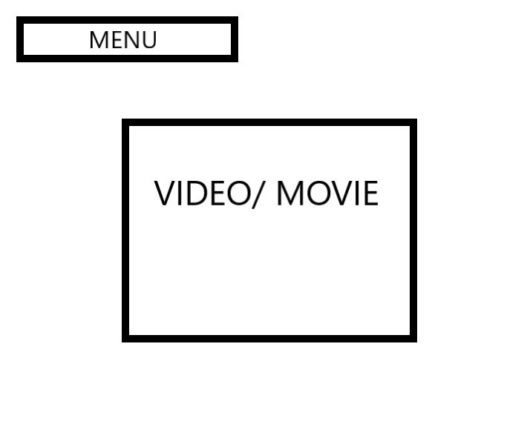

Figure 4 HTML AboutUs Page

Figure 5 HTML Contact Page

Figure 6 HTML SignUp Page

**Physical Design**

**SQL Code.**

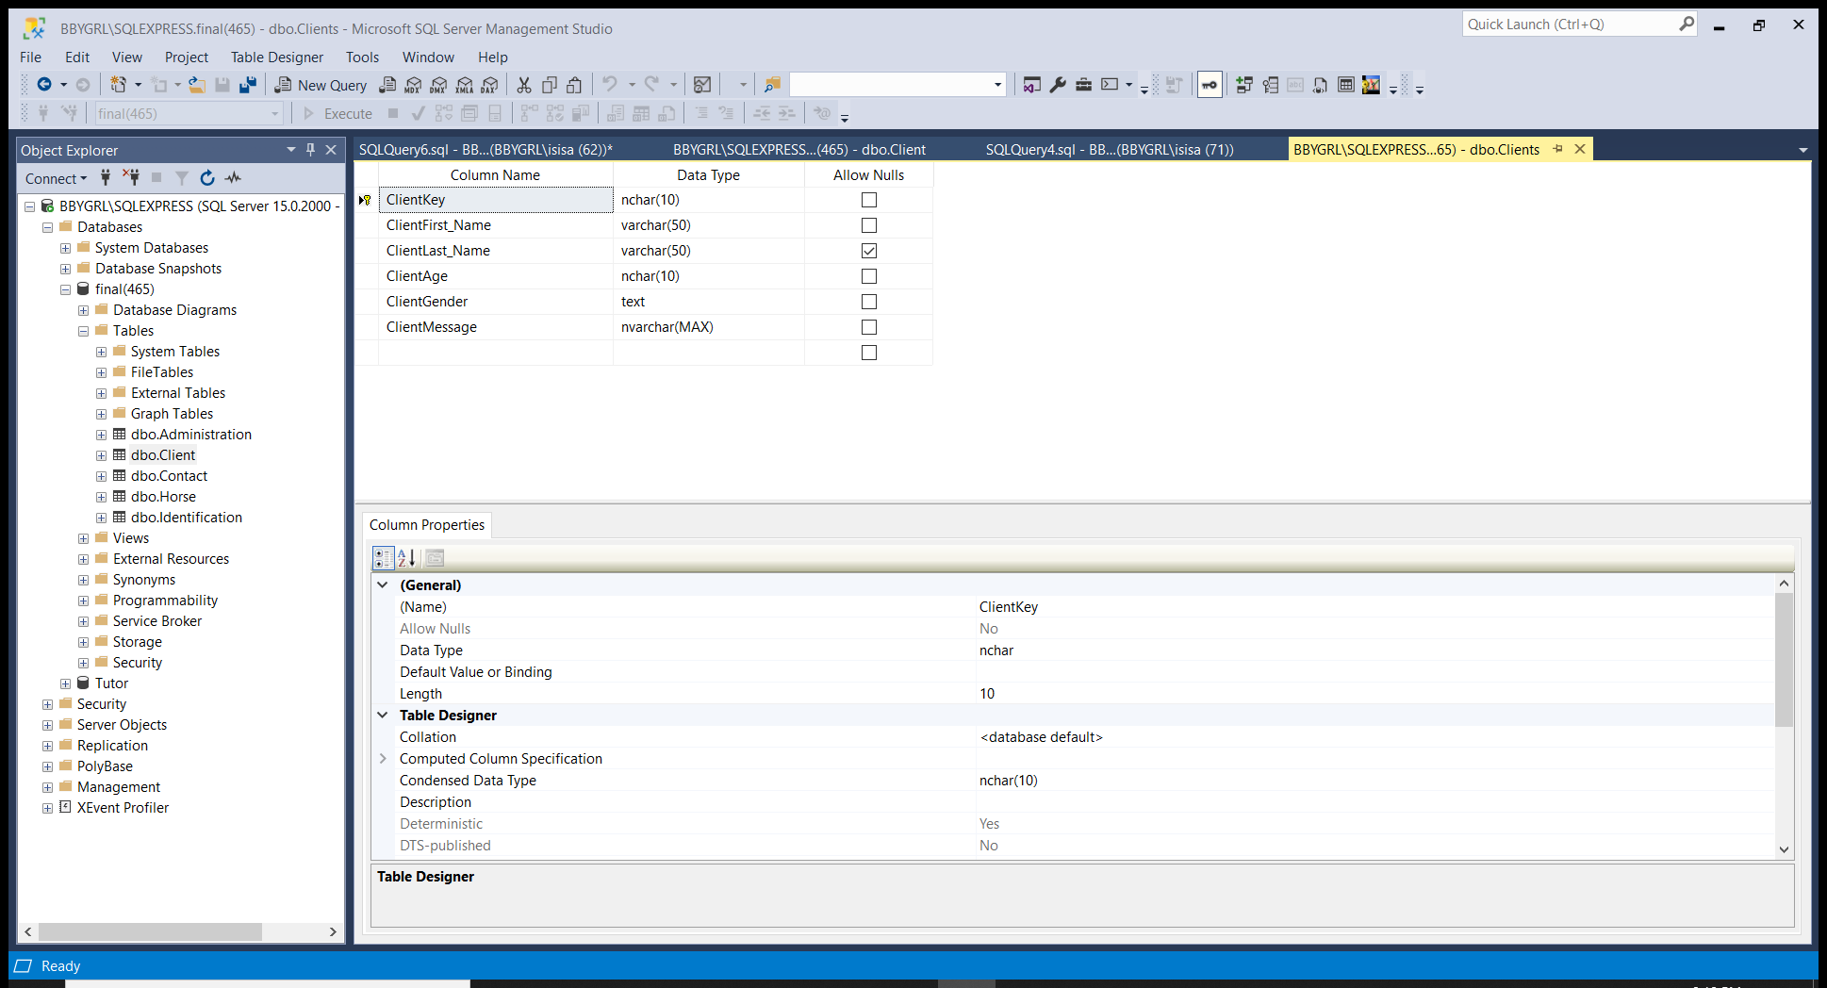

Table 1 Client Table Design

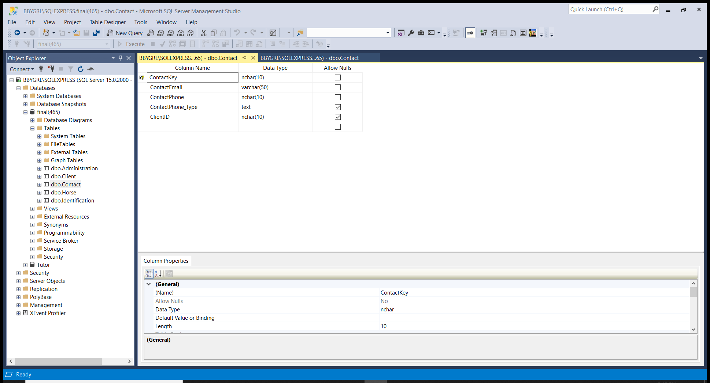

Table 2 Contact Table Design

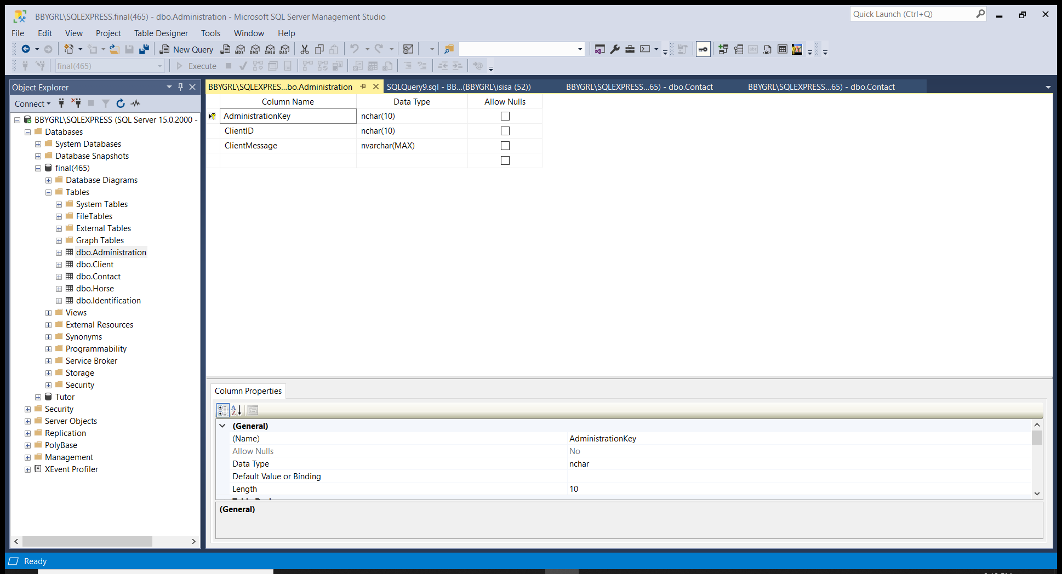

Table 3 Administration Table Design

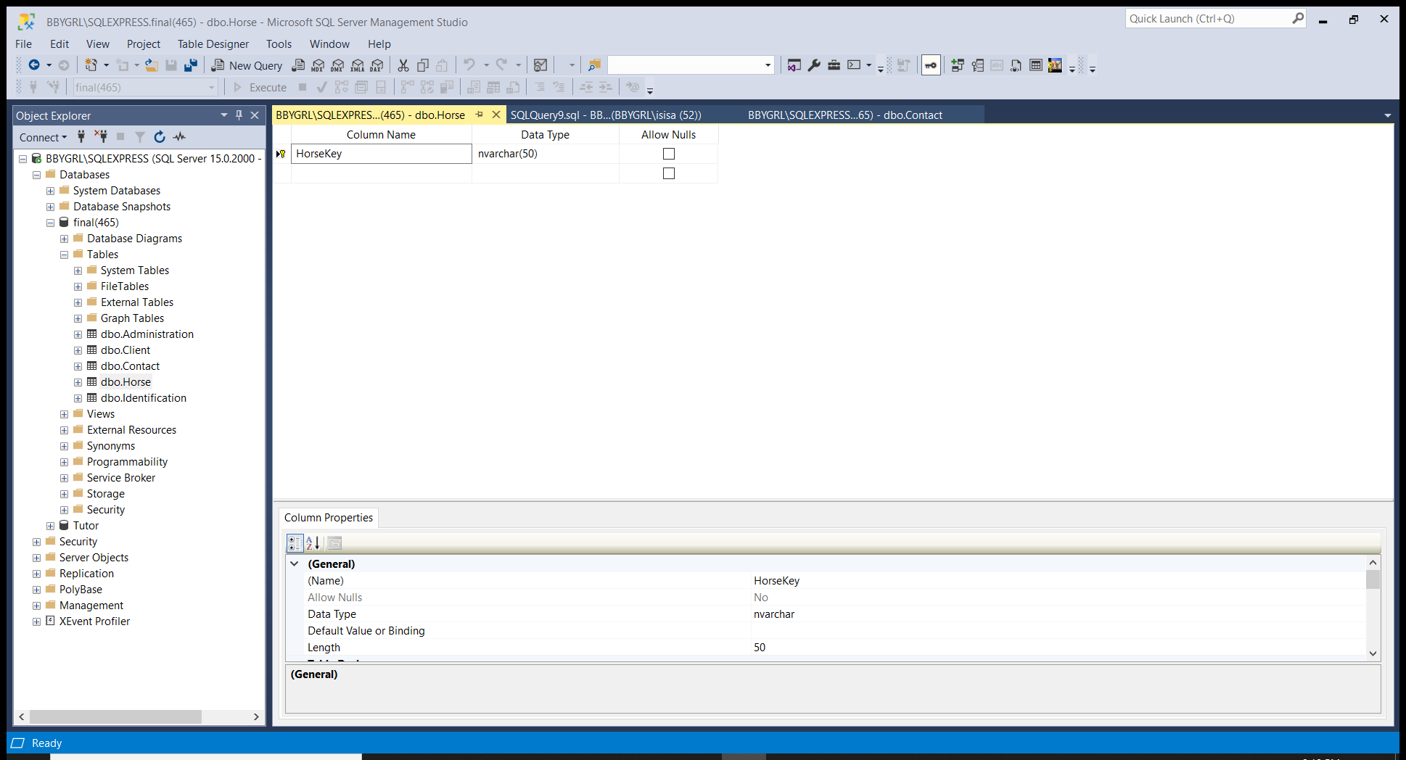

Table 4 Horse Table Design

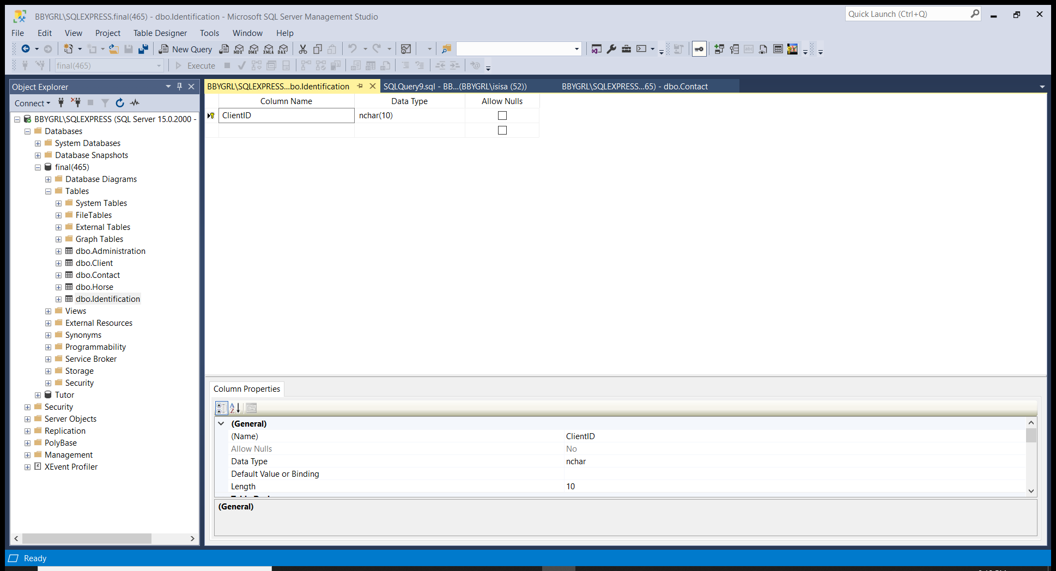

Table 5 Identification Table Design

**HTML Design.**

Figure 1-1 Home/Index Page

Figure 1-2 Chatbot

Figure 1-3 About Us

Figure 1-4 Contact Page

Figure 1-5 Sign Up Price

Figure 1-6 Submit Button

Figure 1-7 Thank You Page

**User Interface Design**

As previously mentioned, the software of my choice to create an HTML document was none other than Visual Code Studio. In former classes, I have used this software above notepad++ or brackets which seemed to be the most common amongst my peers. After doing research and taking multiple classes which involved web development, I was able to gain comfortability with using this software. One of its features that grabbed my attention was its ability to access a live server. With this server I was able to save the HTML code and the web page would automatically update. With over 500 lines of code my web page is designed for user friendly interactions, yet it displays all the information necessary.

Below are lines of code which include the final physical design of my web page along with the sign-up page which is the most important. Once accessing the signup page, you can see prices and fill out a form of your information. This page is designated to future clients who want to tell me a little bit about their riding experience. If there are any questions or concerns throughout the process of accessing this web page on the home screen, there is a chat bot built using the software Landbot.io. It asks the users questions to help direct them to the correct page.

**Index/Home Page.**

<!DOCTYPE html>

<html lang="en">

<head>

    <meta charset="UTF-8">

    <meta name="viewport" content="width=device-width, initial-scale=1.0">

    <title>Final Project</title>

    <link rel="stylesheet" href="styles.css"> <!-- Linked to stylesheet -->

</head>

<style>

    .content {

      max-width: 500px;

      margin: auto;

    }

    </style>

<body>

<script SameSite="None; Secure" src="https://static.landbot.io/landbot-widget/landbot-widget-1.0.0.js"></script>

    <script>

      var myLandbot = new LandbotLivechat({

        index: 'https://chats.landbot.io/v2/H-736895-PGZOH53ARDMPMR6L/index.html',

      });

</script>

<img src="images/logo.png" alt="Riding Lessons Logo">

<header>

    <nav><!-- Linked to other pages -->

        <ul>

            <li><a href="index.html">Home</a></li>

            <li><a href="aboutus.html">About Us</a></li>

            <li><a href="contact.html">Contact</a></li>

            <li><a href="signup.html">Sign Up</a></li>

        </ul>

    </nav>

    <style>

        body{

            background-image: linear-gradient(to left bottom, #89909b, #818cb2, #8785c5, #9e77cf, #bf62cd);

        }

    </style>

</header>

<section>

  <!-- MAIN (Center website) -->

<div class="main">

    <h1>Meet a Few of Our Horses</h1>

    <hr>

    <!-- photo Grid -->

    <div class="row">

      <div class="column">

        <div class="content">

          <img src="images/gold.jpg" alt="Gold Man" style="grid-auto-columns: auto;">

        </div>

      </div>

      <div class="column">

        <div class="content">

          <img src="images/sam.jpg" alt="Samson" style="grid-auto-columns: auto;">

        </div>

      </div>

      <div class="column">

        <div class="content">

          <img src="images/sammie.jpg" alt="Samson" style="grid-auto-columns: auto;" width="225px" height="300px">

        </div>

      </div>

      <div class="column">

        <div class="content">

          <img src="images/nel.jpg" alt="Juice" style="grid-auto-columns: auto;" width="225px" height="300px">

        </div>

      </div>

    </div>

    <!-- END MAIN -->

    </div>

   <style>

       * {

  box-sizing: border-box;

}

/*css*/

body {

  padding: 20px;

  font-family: Arial;

  cursor: default;

}

/* Center website */

.main {

  max-width: 1000px;

  margin: auto;

}

h1 {

  font-size: 50px;

  word-break: break-all;

  text-align: center;

}

.row {

  margin: 170px -16px;

}

/* Add padding BETWEEN each column (if you want) */

.row,

.row > .column {

  padding: 20px;

}

/* Create four equal columns that floats next to each other */

.column {

  float: left;

  width: 25%;

  position: relative;

}

/* Clear floats after rows */

.row:after {

  content: "";

  display: table;

  clear: both;

  position: relative;

}

/* Content */

.content {

  background-color: white;

  padding: 50px;

  margin: auto;

}

/* Responsive layout - makes a two column-layout instead of four columns */

@media screen and (max-width: 900px) {

  .column {

    width: 50%;

  }

}

/* Responsive layout - makes the two columns stack on top of each other instead of next to each other */

@media screen and (max-width: 800px) {

  .column {

    width: 50%;

  }

}

   </style>

</section>

<!-- table -->

    <link rel="stylesheet" href="https://cdnjs.cloudflare.com/ajax/libs/font-awesome/4.7.0/css/font-awesome.min.css">

<h2>Check to see if your eligible for lessons</h2>

<style>

    h2{

        text-align: center;

    }

</style>

    <table>

      <tr>

        <th style="width:50%">Skills</th>

        <th>Beginner</th>

        <th>Semi-Pro</th>

      </tr>

      <tr>

        <td>Ever been around a Horse?</td>

        <td><i class="fa fa-remove"></i></td>

        <td><i class="fa fa-check"></i></td>

      </tr>

      <tr>

        <td>Ever been on a Horse?</td>

        <td><i class="fa fa-remove"></i></td>

        <td><i class="fa fa-check"></i></td>

      </tr>

      <tr>

        <td>Want to learn more about riding?</td>

        <td><i class="fa fa-check"></i></td>

        <td><i class="fa fa-check"></i></td>

      </tr>

      <tr>

        <td>Eligible?</td>

        <td><i class="fa fa-check"></i></td>

        <td><i class="fa fa-check"></i></td>

      </tr>

    </table>

    <!-- end table -->

    <footer>IEA</footer>

</body>

</html>

**Contact Page.**

<!DOCTYPE html>

<html lang="en">

<head>

    <meta charset="UTF-8">

    <meta name="viewport" content="width=device-width, initial-scale=1.0">

    <title>Final Project</title>

    <link rel="stylesheet" href="styles.css">

</head>

<body>

<header>

    <nav><!-- Linked to other pages -->

        <ul>

            <li><a href="index.html">Home</a></li>

            <li><a href="aboutus.html">About Us</a></li>

            <li><a href="contact.html">Contact</a></li>

            <li><a href="signup.html">Sign Up</a></li>

        </ul>

    </nav>

</header>

<div class="main">

    <div class="row">

        <div class="column">

          <div class="card">

              <style>

                  h2{

                      text-align: center;

                  }

              </style>

            <img src="images/use.png" alt="Isis" style="width:auto">

            <div class="container"></div>

              <h2>Isis E. Adams</h2>

              <p><a>

                My name is Isis Adams and I am the founder of DLP Riding Lessons. I am in the undergrad Information Technology program at Campbell University, set to graduate in May 2021. My business was named in honor of my late grandfather, Dencie Lee Proctor. Although I was not born in time to meet him, his legacy, through stories and recordings, has left a lasting impression on my life. My goal is to help you conqure your fear of horses or just learn how to ride. I pride myself in being the best trainer possible to make your experience pleasant. Below is a video explaining more on how my dream became reality. I hope to see you soon!

            </a></p>

              <p class="title">CEO &amp; Founder</p>

              <p>252.722.5303</p>

              <p>ieadams0301@email.campbell.edu</p>

            </div>

          </div>

        </div>

    </div>

<style>

/* profile boxes css */

body{

            background-image: linear-gradient(to left bottom, #89909b, #818cb2, #8785c5, #9e77cf, #bf62cd);

            background-repeat: no-repeat;

        }

img{

    margin-top: 100px;

        display:block;

        padding: 100px;

}

.main {

  max-width: 800px;

height: 700px;

  margin: auto;

}

.column {

    margin-top: 200px;

  float: left;

  width: 100%;

  margin-bottom: 5px;

  padding: 0 8px;

}

/* Display the columns below each other instead of side by side on small screens */

@media screen and (max-width: 650px) {

  .column {

    width: 100%;

    display: block;

  }

}

/* Add some shadows to create effect */

.card {

  box-shadow: 0 4px 8px 0 rgba(0, 0, 0, 0.2);

}

.container {

  padding: 0 16px;

}

.container::after, .row::after {

  content: "";

  clear: both;

  display: table;

}

.title {

  color:darkgrey;

}

footer{

    font-style: italic;

        position: fixed;

        left: 0;

        bottom: 0;

        width: 100%;

        background-color:none;

        color: black;

        text-align: right;

}

/*end profile css*/

        </style>

<footer>IEA</footer>

</body>

</html>

**About Us Page.**

<!DOCTYPE html>

<html lang="en">

<head>

    <meta charset="UTF-8">

    <meta name="viewport" content="width=device-width, initial-scale=1.0">

    <title>Final Project</title>

</head>

<body>

<header>

    <nav>

        <ul>

            <li><a href="index.html">Home</a></li>

            <li><a href="aboutus.html">About Us</a></li>

            <li><a href="contact.html">Contact</a></li>

            <li><a href="signup.html">Sign Up</a></li>

        </ul>

    </nav>

    <style>

        body{

            background-image: linear-gradient(to left bottom, #89909b, #818cb2, #8785c5, #9e77cf, #bf62cd);

        }

    </style>

    <img src="images/logo.png" alt="Riding Lessons Logo">

 </header>

    <section><a>

 <iframe width="700" height="415" src="https://www.youtube.com/embed/9IvmsBdwwNk" frameborder="0" allow="accelerometer; autoplay; clipboard-write; encrypted-media; gyroscope; picture-in-picture" allowfullscreen></iframe>

</a></section>

<div class="myImg">

</div>

<style>

    img{

        margin: 0;

  position: absolute;

  top: 20%;

  left: 50%;

  height: 300px;

  -ms-transform: translate(-50%, -50%);

  transform: translate(-50%, -50%);

}

header {

    display: inline-flex;

    background-color: none;

    color: black;

    padding: 0px;

    margin: 40px;

    margin-top: 200px;

    font-family: Arial, Helvetica, sans-serif;

}

header a{

color:black;

text-decoration: none;

text-transform: capitalize;

margin-top: 40px;

}

ul{

    margin:0;

    padding: 0;

    list-style-type: none;

    position: fixed;

    right: 80px;

    left:10px;

    top: 20px;

}

li{

    display: inline-block;

    margin-right: 20px;

}

section a {

    background-color: none;

    color:rgb(10, 10, 10) ;

    padding: 140px;

    display: flex;

    flex-direction: column;

    align-items: center;

}

section b{

    display: flex;

    flex-direction: column;

    align-items: center;

}

    footer{

        font-style: italic;

        position: fixed;

        left: 0;

        bottom: 0;

        width: 100%;

        background-color:none;

        color: black;

        text-align: right;

    }

</style>

<footer>IEA</footer>

</body>

</html>

**Sign Up Page.**

<!DOCTYPE html>

<html lang="en">

<head>

    <meta charset="UTF-8">

    <meta name="viewport" content="width=device-width, initial-scale=1.0">

    <title>Final Project</title>

    <link rel="stylesheet" href="styles.css">

    <a href="mailto:ieadams0301@email.campbell.edu"></a><!--mailto tag-->

</head>

<!-- text css -->

<body>

  <h1 class="glow">SIGN UP NOW!</h1>

  <p>All Ages Welcome<br>$30 per hour</p>

<style>

  body {

  background-color: black;

  font-family: cursive;

}

p{

  border: none;

  font-size: 20px;

  color: #700667;

  padding: 0;

}

.glow {

  margin-top: 150px;

  font-size: 80px;

  color: #fff;

  text-align: center;

  -webkit-animation: glow 1s ease-in-out infinite alternate;

  -moz-animation: glow 1s ease-in-out infinite alternate;

  animation: glow 1s ease-in-out infinite alternate;

}

@-webkit-keyframes glow {

  from {

    text-shadow: 0 0 10px #fff, 0 0 20px #fff, 0 0 30px #700667, 0 0 40px #700667, 0 0 50px #d521db, 0 0 60px #7a1458, 0 0 70px #700667;

  }

  to {

    text-shadow: 0 0 20px #fff, 0 0 30px #700667, 0 0 40px #700667, 0 0 50px #cf38af, 0 0 60px #700667, 0 0 70px #700667, 0 0 80px #700667;

  }

}

</style>

<!-- end css-->

<header>

  <nav>

    <ul>

        <li><a href="index.html">Home</a></li>

        <li><a href="aboutus.html">About Us</a></li>

        <li><a href="contact.html">Contact</a></li>

        <li><a href="signup.html">Sign Up</a></li>

    </ul>

  </nav>

  <style>

    header a{

      color: white;

      font-family: Arial, Helvetica, sans-serif;

    }

    footer{

      color: white;

      font-family: Arial, Helvetica, sans-serif;

    }

  </style>

</header>

<!-- start form -->

<section><b>

    <div class="container">

        <form action="thankyou.html">

          <label for="fname">First Name</label>

          <input type="text" id="fname" name="firstname" placeholder="You name..">

          <label for="lname">Last Name</label>

          <input type="text" id="lname" name="lastname" placeholder="Your last name..">

          <label for="Ages">Age Group</label>

          <select id="Ages" name="Ages">

            <option value="3-5">3-5</option>

            <option value="6-10">6-10</option>

            <option value="11-15">11-15</option>

            <option value="16+">16+</option>

          </select>

          <input type="checkbox" id="gender1" name="gender1" value="female">

          <label for="gender1"> Female</label><br>

          <input type="checkbox" id="gender2" name="gender2" value="male">

          <label for="gender2"> Male</label><br>

          <br>

          <label for="email">Email</label>

          <input type="text" id="email" name="email" placeholder="johndoe@gmail.com">

          <label for="phone">Phone Number</label>

          <input type="number" id="phone" name="phone" placeholder="111-222-3333">

          <select id="phone" name="phone">

            <option value="mobile">Mobile</option>

            <option value="home">Home</option>

            <option value="other">Other</option>

          </select>

          <label for="country">Country</label>

          <select id="country" name="country">

            <option value="usa">USA</option>

            <option value="australia">Australia</option>

            <option value="canada">Canada</option>

          </select>

          <label for="message">Message</label>

          <textarea id="message" name="message" placeholder="Tell us what times work for you.." style="height:200px"></textarea>

          <input type="submit" value="Submit">

          <location class="href" ></location>

        </form>

      </div>

    </b></section>

    <!-- end form -->

<footer>IEA</footer>

</body>

</html>

**Thank You Page.**

<html>

<body>

    <head>

    <img src="images/11-113352_thank-you-thank-you-for-signing-up.png" alt="Thank You">

<link rel="signup" href="signup.html">

<link rel="contactinfo" href="Contact Information.html">

<button onclick="goBack()">Go Back</button>

<script>

function goBack() {

  window.history.back();}

</script>

</head>

</body>

<style>

    img{

        margin-left: auto;

        margin-right: auto;

        display: block;

    }

    button{

        background-color: teal;

        color: white;

        padding: 10px;

        margin-top: 50px;

        display: block;

        margin-left: auto;

        margin-right: auto;

    }

    body{

        background-color:white;

    }

</style>

</html>

**CSS Page.**

/*universal css for all pages*/

body{

    font-family: Arial, Helvetica, sans-serif;

    margin:0;

    padding:0;

}

img {

    margin: 0;

  position: absolute;

  top: 20%;

  left: 50%;

  height: 300px;

  -ms-transform: translate(-50%, -50%);

  transform: translate(-50%, -50%);

}

header {

    display: inline-flex;

    background-color: none;

    color: black;

    padding: 0px;

    margin: 40px;

    margin-top: 200px;

}

header a{

color:black;

text-decoration: none;

text-transform: capitalize;

margin-top: 40px;

}

div{

    background-color:none;

    align-content: flex-end;

}

section a {

    background-color: none;

    color:rgb(10, 10, 10) ;

    padding: 40px;

    display: flex;

    flex-direction: column;

    align-items: center;

}

section b{

    display: flex;

    flex-direction: column;

    align-items: center;

}

ul{

    margin:0;

    padding: 0;

    list-style-type: none;

    position: fixed;

    right: 80px;

    left:10px;

    top: 20px;

}

li{

    display: inline-block;

    margin-right: 20px;

}

/*end of universal css*/

/*video on about us page*/

.video{

  display: flex;

  flex-direction: column;

  align-items: center;

}

/*uiversal footer css*/

footer{

    font-style: italic;

        position: fixed;

        left: 0;

        bottom: 0;

        width: 100%;

        background-color:none;

        color: black;

        text-align: right;

}

/*end footer css*/

/*table css on home page*/

p{

    font-size: medium;

    text-align: center;

    margin:0;

    display: flex;

    align-items: center;

    justify-content: center;

    padding:20px;

    border-style: groove;

    border-spacing: 10px;

    border-radius: 10px;

}

table {

    margin: auto;

    padding: auto;

  border-collapse: collapse;

  border-spacing: 0;

  width: 70%;

  border: 1px solid black;

}

th, td {

  text-align: center;

  padding: 16px;

}

th:first-child, td:first-child {

  text-align: left;

}

/* Zebra-striped table rows */

tr:nth-child(even) {

  background-color: #f2f2f2

}

.fa-check {

  color: green;

}

.fa-remove {

  color: red;

}

/*end of table css*/

/*container submition box on sign up page*/

input[type=text], select, textarea {

    width: 100%;

    padding: 12px;

    border: 1px solid #ccc;

    border-radius: 4px;

    box-sizing: border-box;

    margin-top: 20px;

    margin-bottom: 16px;

    resize: vertical

  }

  input[type=submit] {

    background-color: #4CAF50;

    color: white;

    padding: 20px 30px;

    border: none;

    border-radius: 4px;

    cursor: pointer;

  }

  input[type=submit]:hover {

    background-color: #45a049;

  }

  .container {

    border-radius: 5px;

    background-color: #f2f2f2;

    padding: 20px;

    position: absolute;

  }

  /*end submision box*/

**Implementation**

**Conversion.** The data consists of client first name, last name, cell phone number, email address, gender, location, and a brief message they would like to share. This data will be used to contact anyone who submits a from. Administration, I, will be the only one with viewing access and ability to edit. Being that the database is only accessible from my computer I will not have to worry about too many security threats. I must make sure that all this information is encrypted before moving any of the data around.

**Integration.** This phase seemed to be the most complex of them all. Having to implement my pseudocode along with my source code and SQL. The code was not difficult to produce, it was having to link the different software in a way I was not familiar. When creating the SQL, I had to do extensive research on how to get started. Many professional developers have used a multitude of software combinations, but not many like mine.

**Systems Testing and Evaluation**

**System Support Procedures**

If the systems were to fail individually, my first suggestions would be to troubleshoot each software. For the HTML code, it would be simple to see which lines specifically have errors or have been manipulated. This will most likely keep you from losing all the hard work you have put in this far. Like the HTML software, the Management Server Express, would also make it simpler to find errors. Being that these are not accessible to the public yet, when I purchase a domain, the threats will present themselves.

**User Survey(s)**

**Future Enhancements**

In the future, my first task will be to purchase a domain name for the public to access it via the internet. Hopefully, this name will not have to be long, and it can be relatively close to the name of my business. I would also maintain the website’s physical appearance. Maybe changing the background colors from ombre black and purple, to a solid color or just white. It has been said that different colors affect people of all ages differently than one another (Vanessa Van Edwards, 2013). Solid colors with dark lettering are a style that would attract the older generations, while loud, bright colors attract the younger population.

Another enhancement I would make to the website is the chatbot. While this current bot gets the job done, it is not as extensive as I would like it to be. I would like for it to send me the list of dialogues it has throughout the day. A way to monitor how I should change the design in the future, so the users never have to ask a question regarding where things are located. For the structure of this design, I was using a Bing.com style. Bing incorporates boxes, images, videos, and text. This creativity invites the user to look at every aspect of the page because there is always something on the page moving and new to read.

Enhancements to the database would not be as extensive as the website. The most I would need to update is the information requested via the form. I would either take away some of the columns or change relationships to make room for more or to use it to better organize the data. I would also have to add an antivirus encryption on the website in case someone access my source code in attempts to input malicious code. With my initial idea being to connect the database and website, I was unsuccessful so in the future I will make sure this aspect of the system is taken care of.

**Conclusion**

To conclude, my research and design processes have led to a project which displays what I have learned over my years in the department of information technology at Campbell University. All the internet searches and tutorials I utilized throughout the semester have led up to the production of this idea turned reality. To create an important of a business is one accomplishment, but to create it for my business, can update and maintain it have become another accomplishment. I am grateful for the opportunity to express my creativity through such an extensive course with rigorous demands and challenges, motivating me to do my absolute best.